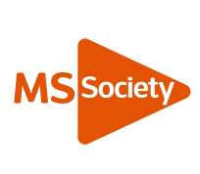
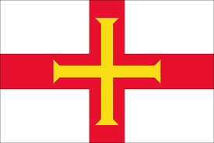
HAPPY NEW YEAR

In this Newsletter

Pages 3 – 5 The Secretary’s pages.
Page 6 - 8. The Chair’s pages
Pages 9 Quiz Night

Page 10 Bingo and Flag Day 2020

Page 11 Sudoko Puzzle

Page 12 – 13. Meet our newest member

Pages 14 Events so far this year

Page 15. Sudoko Answers

From the Secretary

I hope you all had a lovely Christmas and may I take this opportunity to wish you all a Very Happy and Healthy New Year. I am sorry you did not receive a Newsletter at the end of last year, but life took an unwanted turn for me, and I was unable to think about putting a Newsletter together. I am sure you all understand how life can throw things at you that you are not expecting or wanting.

The year ended as it started for the Guernsey MS Society Committee which was very busy! You will be able to read about different events that were held last year later in this Newsletter. I would like to publicly thank all the MS Committee who work very hard to keep the awareness of MS in Guernsey in the public eye, and who organize many fundraising events to help support all those on Guernsey affected by MS.

The Christmas Fayre went extremely well and thank you to all who came and supported it. It does give us the opportunity to meet up with friends and family. We raised a considerable amount of money, a large portion of this was from the raffle. I am always delighted by the kindness of both individuals and businesses when asked to donate something for the raffle.

I have never had my own stall so I was perhaps not fully aware of the amount of time it takes to set up a stall. Many of our stall holders arrived a couple of hours before opening to set up their tables, which all looked amazing.

Maggie helping to set up the raffle. There were some
beautiful colours.

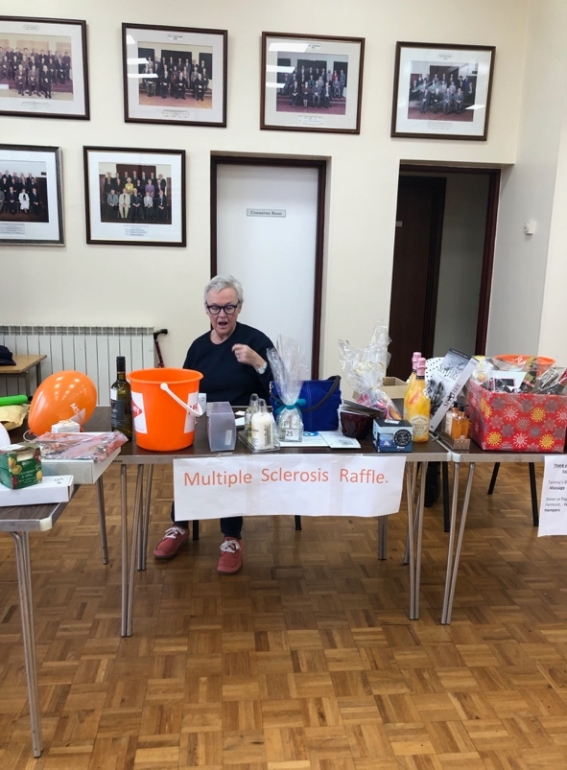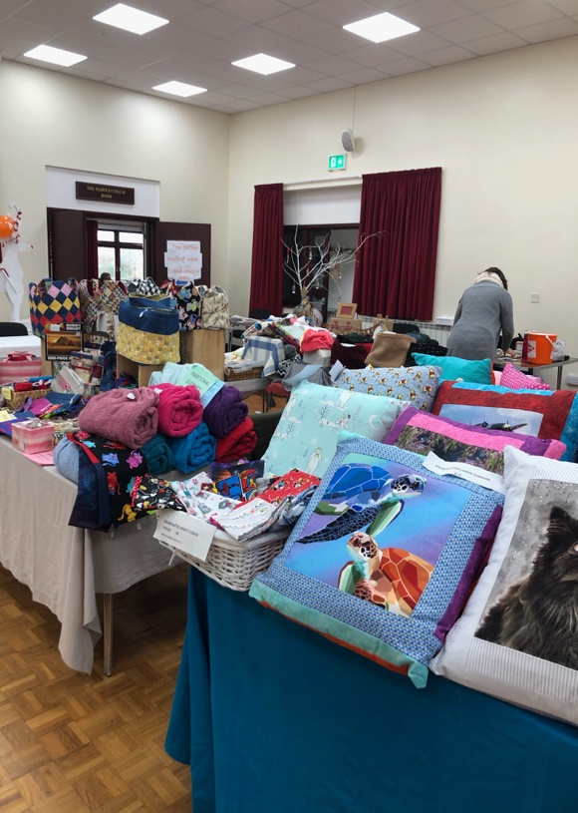
And then we were underway. Sue with her wonderful
homemade crafts.
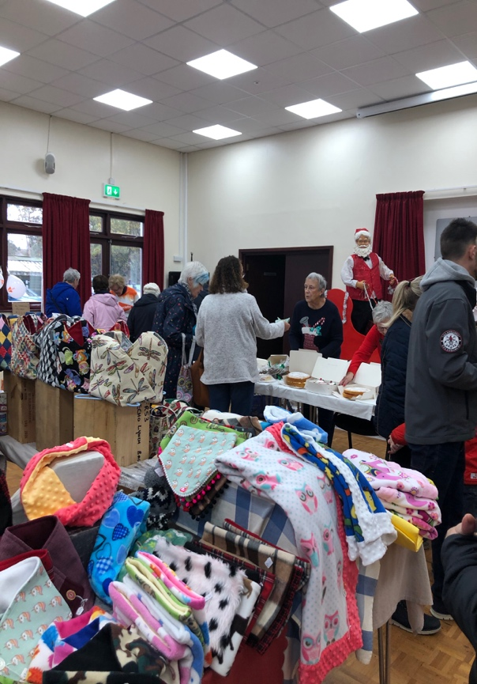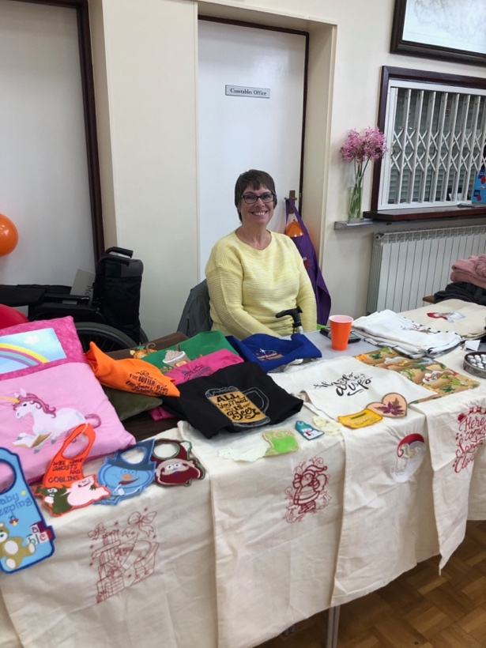

The Charities Christmas Fayre was held on Sunday Nov 17th 2019 at Beau Sejour. This was only the second time we have participated in this event, and for those of you who don’t know it, it is quite an occasion! 63 charities took part and the event ran from 10am - 4pm – this is why we always ask for volunteers, as we need a rota and at peak times it can get very busy!!
We sold CD’s and DVD’s, kindly donated by many of you, and also had a Lucky Dip for the children. The photo shows some of us manning the stall and you can tell that we have a good time (as well as making a bit of money and raising awareness of MS!!)
In 2020, the Fayre will be on November 22nd, so why not put the date in your diary now and perhaps come and help us on the stall....??

I have given you a Sudoko puzzle in this Newsletter. Just in case you have not completed one before here are the rules.
Fill in the grid with digits in such a manner that every row, every column and every 3x3 box accommodates the digits 1-9, without repeating any.

Gill Ford
Secretary

From the Chair

First and foremost, Happy New Year and new decade.
1. A couple of updates about on-going issues:
A). Our case for a second specialist nurse was re-submitted to HSC in November. Although we had originally presented it way back in May, some updated activity figures were required from HSC. These took a while to compile, and when received the caseload numbers for MS for 2018 implied that we had lost about a third of our number!! This was clearly incorrect and largely stemmed from a ‘re-categorisation’ of Debbie’s caseload. Remember that there are no island-wide figures collected for MS, so we had previously relied on Debbie’s records. However, this‘re-categorisation’, whilst appropriate for management decisions, was singularly unhelpful to us. Therefore, together with Terry March from the Parkinsons Disease Society, we approached all the GP surgeries asking if they could just give us the number of people with MS living in Guernsey (with sincere apologies to Sark, Herm and Alderney who we overlooked). This enquiry gave us a figure of 212 (previously 146 in 2017) so helped us to make the case of an increasing workload. Now the Business Case is undergoing ‘prioritisation’; I didn’t get the impression this would be a speedy process, but now Christmas is over we will start asking about progress.
Shortly after our re-submission, I was telephoned by the BBC about doing an interview about the shortage of Specialist nurses! This related to a news item from the MS Trust UK which fortuitously was being released the following day. So we had an airing on BBC news and this was heard by Channel TV who then came and did another piece, this time about OUR nurse, which went out on the 13.00 and 18.00 Channel news bulletins on November 27th. All good publicity!
B.Disease Modifying Therapies (DMT’s).
At the time of the review of NICE recommended treatments, not available in Guernsey, (Spring 2019) the following 3 drugs were not available to us; Aubagio (Teriflunomide), Mavenclad (Cladribine) and Ocrevib (Ocrelizumab)
The report of the review recommended a phased introduction of various drugs over a two year period. Teriflunomide and Cladribine were included in Phase 1 and Ocrelizumab in Phase 2 {in fact Cladribine became approved for use in July 2019 and at least one person is now receiving it}.
The start of the phased introduction has been pushed back to touch with Mike Read (chair of HEAL) who is very active in this area.

2. Neurology provision

Dr Oswald retired from MSG at the end of last year. His specialist interest of Diabetes and Endocrinology has been covered with a new consultant appointment, but his general medical interest (which also included MS) has not been replaced. Furthermore, Dr Slaght, the neurologist who visits from Southampton once a month, will stop coming to Guernsey in the middle of 2020. This leaves us with Dr Steve Evans seeing ‘early’ or ‘possible MS’ cases and Dr Matthews (movement disorders e.g. Parkinsons) sees people for ‘rehab’ and symptom management.
I have written to Dr Peter Rabey at PEH, copied to Heidi Soulsby, Steve Evans, Sarah Hansmann-Rouxel and the GDA, asking for information on this situation. I have been assured that they are working on it and are looking at a number of possible solutions. I will keep you informed.

3. Use of a Mobile Home in France from ?April 2020

...and now some cheerful news!! David Woodland who has become very friendly with Terry March (chair of The Parkinsons Disease Society) advised Terry that he wishes to purchase a mobile home, to be located in Northern France, about 40 mins from St Malo. This will be fully equipped and suitable for those with disabilities. The home will be made available to people with MS or Parkinsons and their families/friends/carers and will be FREE OF CHARGE. The home is already on order. Details of the scheme and how to book a stay will be made available as they become known.

Finally, we welcome a new committee member, Jennifer Merrett who introduces herself to you, elsewhere in this newsletter – welcome Jennifer!

There are some interesting events being planned as detailed in other sections of the newsletter. We always need help at these events and even if you can’t help, just coming along to support is always welcomed. Our first event is 7th Rowathon on February 9th – put it in your diaries now and I look forward to meeting some of you during the year.

Linda Fermont

MS Quiz Night held at Mint Restaurant.

Following a successful Quiz evening in April 2019, the committee felt that as the response was so positive, we should host another Quiz evening. It was decided to use the same venue, which was Mint (formerly The Last Post), and the date was 24th October 2019.
Once again word travelled fast and bookings came in regularly and it appeared there was no need to advertise the event as all the tables were filled quickly. The venue was able to offer 11 tables for 6 people. Mr Sean McManus was the Quizmaster, and accompanied by his wife and 2 helpers they offered a varied selection of questions and contributed to making the event a really good fun evening, with much banter and laughter.
The winners of the Quiz 1st and 2nd Prizes received bottles of wine. There was also a great selection of raffle prizes, including voucher for dinner at Mint Restaurant, trip to Herm and food vouchers and more.
The Mint offered a selection of three food choices, including the ever popular curry and a vegetable option. The atmosphere was relaxed and everyone appearing to enjoy the evening with lots of humour and laughter.
So, we wish to say a Big ‘thank you’ to everyone that supported the MS Society (Guernsey) and contributed to making the evening a good one.

Jacquie Vining
Committee Member

Bingo and Flag Day

Save the date

A fun evening of Bingo, is to be held on Friday March 13th 2020 at La Nouvelle Maraitaine. The Secretary of the resident’s association, Yvonne and her husband, Terry, have very kindly offered to run the Bingo and a raffle for us.

Supper will be provided by Café Amiti, at La Nouvelle Maraitaine, for just £7 per head. More details on food choices will follow soon.

Diary reminder

Our annual Flag Day, which is a big fundraising event for MS, will be on Saturday 25th April 2020. We are always looking for flag sellers during the hours of 8am and 5pm at all the major stores. If you could spare an hour or two please register your interest with either Jacquie at jvining@live.co.uk or Pauline at randpclarkson@cwgsy.net

Many thanks

Pauline Clarkson
Committee member

Meet the newest member of the Committee
Jennifer Merrett

I was incredibly privileged to have a mother, whom although diagnosed with MS when I was just a few years old, fought long and hard to try to give us a childhood that contained many happy memories, but due to declining health , some very sad ones.

I cannot recall a time when my mother was well and able to join in as other parents could, especially when it came to physical aspects of life, but I can recall the laughter and love that she gave me. The memories, support and guidance that have undoubtedly made me the person I am today.

After she died and when I became old enough, I decided to leave England and lucked out when I found the safe haven of Guernsey. Andrew and I thought at first it would be a stepping stone to the world at large. But we soon realised that in fact, it would be a safe leap pad for our wandering lust for adventure whilst still be able to get back to England, when needed by our extended family.

That was many decades ago, but whereas you can’t choose where you are born, some us can choose where we call home.

Guernsey is our home and we are incredibly lucky to be raising our family on these shores, to be healthy, happy and have a home filled with love and laughter.

Andrew and I have had to work incredibly hard, sometimes holding down more than one full time job to enable us to build a life in Guernsey.

We are both committed to helping our community as and when we can and although undoubtedly a challenge, it will be a privileged to serve on the MS committee.

Events arranged so far this year

February 9th – Rowathon
March 13th - Bingo
May 16th – AGM. Details to follow.
November 7th – MS Christmas Fayre
November 22nd – Charities Christmas Fayre

Sudoku Puzzles Answers

Sudoku Puzzle 1 Solution

2 | 5 | 8 | 9 | 6 | 7 | 3 | 1 | 4
9 | 4 | 6 | 8 | 1 | 3 | 7 | 5 | 2
1 | 7 | 3 | 5 | 4 | 2 | 9 | 6 | 8
7 | 6 | 5 | 1 | 3 | 4 | 2 | 8 | 9
8 | 3 | 1 | 7 | 2 | 9 | 6 | 4 | 5
4 | 2 | 9 | 6 | 8 | 5 | 1 | 7 | 3
6 | 9 | 4 | 3 | 7 | 8 | 5 | 2 | 1
5 | 1 | 2 | 4 | 9 | 6 | 8 | 3 | 7
3 | 8 | 7 | 2 | 5 | 1 | 4 | 9 | 6

Sudoku Puzzle 2 Solution

3 | 6 | 4 | 5 | 7 | 9 | 2 | 1 | 8
1 | 5 | 8 | 2 | 3 | 6 | 7 | 9 | 4
7 | 9 | 2 | 1 | 4 | 8 | 6 | 5 | 3
9 | 3 | 1 | 6 | 8 | 7 | 4 | 2 | 5
2 | 4 | 5 | 9 | 1 | 3 | 8 | 6 | 7
8 | 7 | 6 | 4 | 2 | 5 | 9 | 3 | 1
4 | 2 | 3 | 7 | 9 | 1 | 5 | 8 | 6
6 | 1 | 7 | 8 | 5 | 2 | 3 | 4 | 9
5 | 8 | 9 | 3 | 6 | 4 | 1 | 7 | 2

